**Intermountain Healthcare Epic Hyperspace Installation & First Use Guide**

***Note:*** *Your access to Epic Hyperspace must be added by either the Medical Staff Office (if you are a Credentialed/Privileged Provider) or the Affiliated Team (if you are a Surgery Scheduler) before you can successfully log in. If the latter, please contact Affiliated Support at* [*hco@intermountain.co.ihc.com*](mailto:hco@intermountain.co.ihc.com) *if your access to Epic Hyperspace isn’t working.* **IMPORTANT:** Pulse Secure is NOT required for Epic access and causes conflicts with the Hyperspace URL, so **please assure Pulse Secure is NOT connected.**

**1.** 2-Factor Authentication (2FA) for your Intermountain account is required and, if you don’t have it, go to the [Affiliated Support Services](https://intermountainhealthcare.org/for-professionals/affiliated-support) site -> **2-Factor Auth / Portal / Email Resources** and follow the *Ping ID 2-Factor Auth Setup Guide*.

**2.** Assure that the current version of Citrix Workspace is installed. If not, or if you are unsure, go the applicable Citrix Workspace download page linked at the right then download/install it: [**Windows 10/11**](https://www.citrix.com/downloads/workspace-app/windows/workspace-app-for-windows-latest.html)[**Mac OS**](https://www.citrix.com/downloads/workspace-app/mac/workspace-app-for-mac-latest.html)

**3.** Go to the Intermountain Citrix Storefront site by opening a web browser e.g., Edge, Chrome, Firefox or Safari to <https://apps.intermountain.net>

**4.** Enter your Intermountain User name, Password and choose an option from the Authentication Method dropdown: **PingID Push** sends a prompt to the PingID app OR **One-Time Passcode** allows you to enter the 6-digit code from PingID or an Authenticator app. Then, click *Log On* and complete authentication.

**5.** For first time setup, you will likely need to agree to Citrix Workspace detection then allow Citrix Workspace to launch, similar to below:

**6.** Once logged in, you should see options, as shown below. Click **PRD HyperSpace MT** (as circled) and Hyperspace will launch in a new Citrix Workspace window.

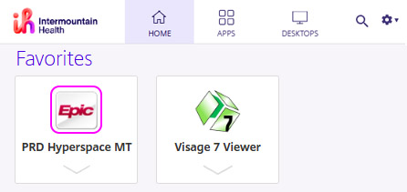

**7.** While at this page, you may want to save it to your Bookmarks/Favorites by clicking the star at the right end of the address bar:

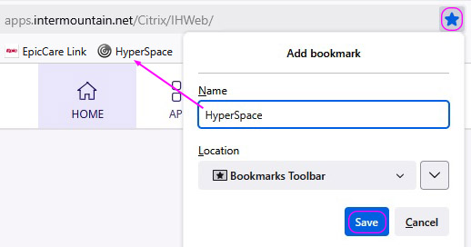

**8.** After a brief wait, Hyperspace will begin launch in Citrix Workspace. Once you enter or confirm your Department (which will likely be different than the example below) and click **Continue**, the Hyperspace environment will launch:

